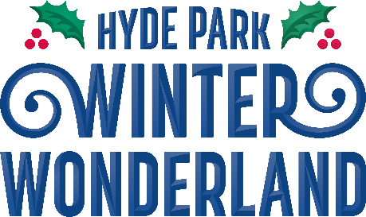


Guide Sheet: Travelling to Hyde Park Winter Wonderland
As the park is based in the centre of London there are a variety of transport options. Below we have provided various map links to areas in the park. This year we are using an app and website called
///What.three.words. This app allows us to provide precise locations without having to give long google addresses of complicated coordinates.
Details about the app can be found here: https://what3words.com/about/
Click on the links to see a map of the locations.

Which entrance?

Attraction | Nearest Gate | ///what.three.words | Nearest Tube station
Ice Rink | Blue Gate | what3words address:///open.limit.gold | Victoria, Green Park, Hyde Park Corner and Knightsbridge
Magical Ice Kingdom | Gold Gate | what3words address:///invest.palms.chair | Bond Street, Paddington and Marble Arch.
The Giant Wheel | Gold Gate | what3words address:///relate.city.couple | Marble Arch
Bar Ice | Gold Gate | what3words address:///eggs.pets.fumes | Bond Street, Paddington and Marble Arch.
Zippos Christmas Circus | Gold Gate | what3words address:///marked.fake.think | Marble Arch
Cirque Berserk | Gold Gate | what3words address:///marked.fake.think | Marble Arch
Ice Sculpting Workshops | Gold Gate | what3words address:///famed.card.scrap | Marble Arch
Bavarian Village | Green Gate | Locate the Bavarian Village Entrance here:///fears.wake.pasta | Knightsbridge

Driving
If you need to drive to the event there are several options for parking around Hyde Park. The event post code is W2 2UH. Below are five options for disabled parking situated around Hyde Park:

Parking bays, West Carriage Drive. 4 Disabled spaces. Located here:
///menu.pouch.rubble https://w3w.co/menu.pouch.rubble
These car parking bays are 1.2 km from the nearest Winter Wonderland entrance (Green Gate) accessible on tarmacked paths which are mostly flat.
- Parking bays, West Carriage Drive. 2 Disabled spaces. Located here:
///slimy.metro.repair https://w3w.co/slimy.metro.repair
These car parking bays are 1km from the nearest Winter Wonderland entrance (Green Gate) accessible on tarmacked paths which are mostly flat.

The Serpentine Carpark, West Carriage Drive. 3 disabled spaces. Located here:
///stream.ozone.pies https://w3w.co/stream.ozone.pies
This carpark is 1.1km from the nearest Winter Wonderland entrance (Green Gate) and is accessible on tarmacked paths that are mostly flat.

The Triangle Carpark, West Carriage Drive. 6 disabled spaces. Located here:
///strict.breath.diary https://w3w.co/strict.breath.diary

This carpark is 850 metres from the nearest Winter Wonderland entrance (Green Gate) accessible on tarmacked paths that are mostly flat.

- The Qpark, Park lane. 8 Disabled spaces, Height restriction 2.08m. Located here (also accessible from Marble Arch):
///medium.remote.fortunate https://w3w.co/medium.remote.fortunate
This carpark is underground, but there are lifts to ground level. This Carpark is 550 metres from the nearest Winter Wonderland entrance (Gold Gate) accessible on paved paths which are mostly flat.
Details for Disabled parking restrictions around the area are available on the Westminster Website available here: https://www.westminster.gov.uk/disabled-parking
Details for booking parking:
Marble Arch and Park Lane: https://www.q-park.co.uk/en-gb/cities/london/marble-arch/
Queensway: https://www.q-park.co.uk/en-gb/cities/london/queensway/

Public Transport Train
The nearest mainline train station is Victoria Station. This station has step free access. Victoria is 1.4 km from the nearest Winter Wonderland entrance (Blue Gate) accessible on paved and tarmacked paths that are mostly flat. Please also note that there are several main roads to cross on this route.

Tube
There are many tube stations in close vicinity to the event including:

Green Park
This is the best station for Wheelchair users.

The station is 1.3 km to the nearest Winter Wonderland entrance (Blue Gate) accessible on paved and tarmacked paths which are mostly flat. The advised route from Green Park for wheelchairs is to exit into Green Park via the long ramp in the station and turn right at the top. (There is a lift to street level if this is preferred).
The Park is tarmacked and can be followed all the way through the park (past the Bomber Command memorial) and out to the Hyde Park Roundabout.
Cross the road here and walk through Wellington Arch. Follow this Path and you will be at the Hyde Park Corner crossing. From here follow signs to the event to get to the Blue Gate.

Bond Street
There is a lift to street level at Bond Street Station and step free access if coming on the Jubilee line.

The station is 1.2 km to the nearest Winter Wonderland entrance (Gold Gate) accessible on paved and tarmacked paths which are mostly flat.

There are several routes from Bond Street including a couple of quiet routes that avoid Oxford Street.

Knightsbridge
There is no step free access at this station and no lift to the street.

The station is 500 metres from the nearest Winter Wonderland entrance (Green Gate) accessible on paved and tarmacked paths that cross a sandy horse-riding track. There is also a slight ramp for 20 metres just after the Horse track.

This is a quiet route into the event, however it is not suitable for wheelchair users.

- Marble Arch
There is no step free access at this station and no lift to the street.

The station is 600 metres from the nearest Winter Wonderland entrance (Gold Gate) accessible on paved and tarmacked paths and crossing several main roads.

On peak days and evenings this station is extremely busy.

- Hyde Park Corner
There is no step free access at this station, however it does have ramps to the street.

The station is 350 metres from the nearest Winter Wonderland entrance (Blue Gate) accessible on paved and tarmacked paths.

On peak days and evenings this station is extremely busy.

- Victoria

This station has a lift to the street from the Victoria Line.

Victoria is 1.4 km from the nearest Winter Wonderland entrance (Blue Gate) accessible on paved and tarmacked paths which are mostly flat. There are several main roads to cross on this route.

By Taxi:
The closest taxi provision for Hyde Park Winter Wonderland is located to the north of the site on the

northbound carriageway of Park Lane.
The taxi rank is 220 metres from the nearest Winter Wonderland entrance (Gold Gate/Red Gate) accessible on paved and tarmacked paths.
There are lots of Black Cab taxi ranks around Hyde Park that are easily accessible from any gate, please see the map on the next page for just some of the options available. Please do not try and hail a cab on a busy road where the driver may have difficulty safety stopping.
Private Hire Cars
If you are using a private hire company, please be considerate when arranging a convenient location for the driver to pick you up, avoiding busy roads or small residential streets where possible.

By Bus:
There are a range of buses that can be used to get to the event. Gold Gate, Red Gate and Blue Gate entrances are serviced by bus stops that have large number of buses stop at them.
London buses can accommodate one wheelchair up to 70cm in width and 120cm in length. All are fitted with retractable ramps.

Gold Gate (Marble Arch):
- Stopping at Bayswater Road (Stop A and Stop D)
Bus numbers 94, 148 and 274

Stop A (buses going East to West) is 400 metres on paved and Tarmacked paths to the Gold Gate.

Stop D (buses going West to East) is 550 metres on paved and tarmacked paths to the Gold Gate. You will need to cross one main road on this route.

Stopping at Marble Arch (Stop W and Marble Arch Station/Park lane)
Bus numbers 2, 6, 10, 13, 16, 36, 74, 137, 148, 390 and 414
Stop W (buses going South to North) is 300 metres on paved and Tarmacked paths to the

Gold Gate.
Marble Arch Station/Park lane Stop (buses going North to South) is 450 metres on paved and Tarmacked paths to the Gold Gate. You will need to proceed down Park lane and cross the main road at the ‘Animals in War’ Memorial.

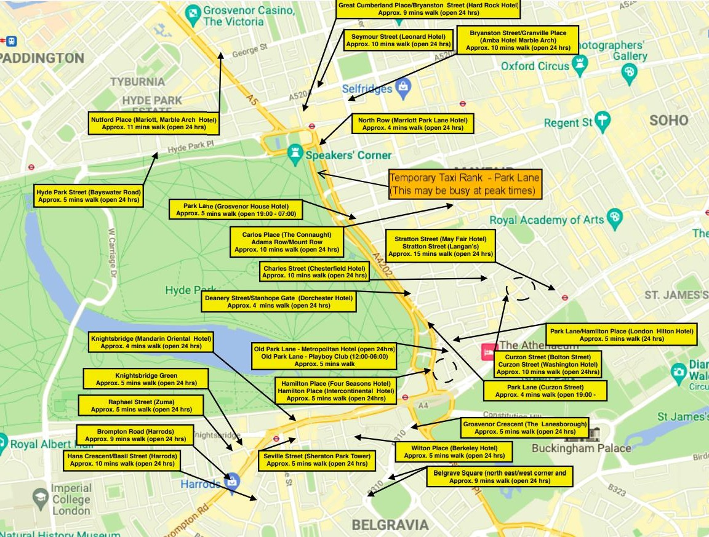
Blue Gate (Hyde Park Corner)
- Stopping at Hyde Park Corner (Stop W, Stop S, Stop P and Stop N)
Bus numbers 9, 10, 14, 19, 22, 52, 74, 137, and 414.

Stop W and Stop S (buses going West to East) are 400 metres on paved and tarmacked paths to the Blue Gate.
Stop P and Stop N (buses going East to West) are 450 metres on paved and tarmacked paths to the Blue Gate. You will need to cross the main road at the Hyde Park corner crossing.

