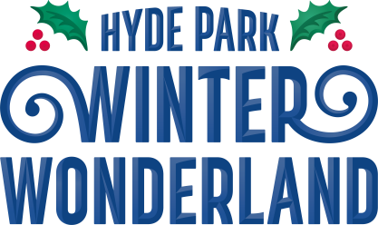

Hyde Park Winter Wonderland 2026/2027 – Access Guide

Where?
Hyde Park Winter Wonderland is located on the Parade Ground on the East side of Hyde Park. There are accessible entrance lanes at all of our entrances.
Red Gate, at the north of the site (See Map), is our Family entrance which is typically quieter than our other entrances. The Blue Gate at Hyde Park Corner and Gold Gate at Marble Arch can get very busy at peak times.
All our entrances are step free, please note that there are bag searches in operation at all of our entrances.
The Following items must not be brought into the event:
- Knives
- Work Tools
- Fireworks (including sparklers)
- Smoke canisters
- Air-horns
- Spray Paint/Cans/large marker pens
- Chinese/Sky Lanterns
- Handheld Communication Devices (such as radios)
- High Visibility Clothing
- Powered or unpowered Skateboards, Scooters, or Bikes
- Flares (such as emergency or distress flares manufactured for legitimate military, maritime, or transport purposes)
- Offensive weapons/potential weapons/anything adapted for such purpose.
- Any object/ item considered to be potentially dangerous or harmful to public safety being a single item or a potential component part for another object.
- Laser devices
- Bottles (unless empty, non-glass)/ glass vessels (including bottle/ cans- even if wrapped up as a present for a later time
- Your own alcohol – even if wrapped up as a present for a later time.
- CS Gas Poles
- Unmanned Aerial Vehicles (UACs) commonly known as “Drones” or “Remotely Piloted Aircraft”.
- Any article that might be used as a weapon and/or compromise public safety.
- Open bottles of drink/liquid (unopened and sealed bottles of water will be accepted, as will empty reusable cups and bottles)
- Illegal drugs

- Nitrous Oxide (in any form)
- Drug Paraphernalia including Psychoactive Substances and Alkyl Nitrates (otherwise known as Poppers)
- Chairs/Stools
- Banners/Flags
- Sound Systems/items that can amplify sound.
- Corrosive substances including acids and substances which are capable on application to the human body of causing hurt through corrosive action.
- Unauthorised or counterfeit merchandise
- Kites
- Musical instruments
- Counterfeit or forged tickets and wristbands or an access pass of any description
- Unauthorised powered vehicles (motorbikes, quad bikes and buggies)
- Any animals other than dogs
- Unauthorised professional tape recorders, photography, and video equipment Any person in possession of such items will be refused entry to the event.

Accessibility around the site
All our entrances are accessible and step free using the park’s own tarmacked paths. Once you are in the event you will find that the event area is covered entirely in temporary trackway.
An example of the temporary trackway used throughout the event:

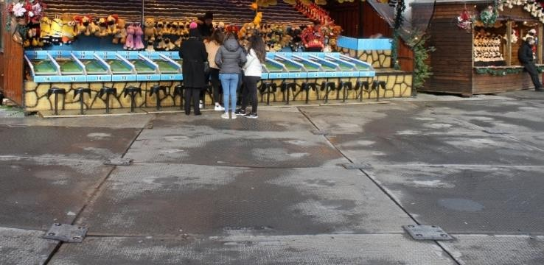

Please bear in mind that temporary track can be uneven at times and not completely flush to the ground due to its impermanent nature.
An example of the paths that surround the event:
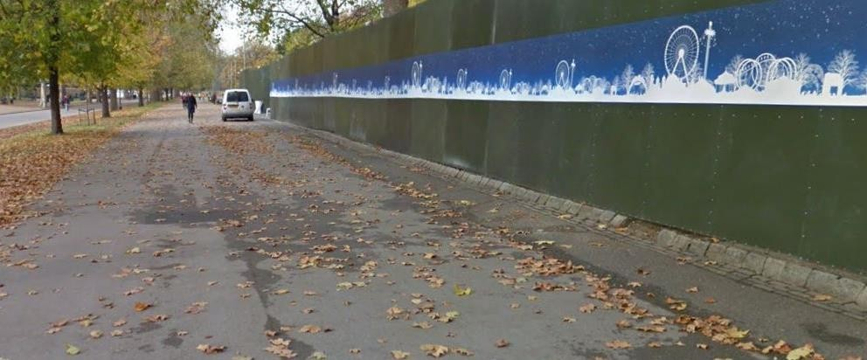

Throughout the event we have endeavoured to ensure that our attractions, games, catering, and toilets are as accessible as possible. This includes ramps and handrails to catering areas, lowered counters in our Box offices and Information Points, and hearing loops in the Circus.
However, please be aware that due to the natural landscape of the park the ground may be uneven in places.

Gates:
All gates have separate lanes exclusively for access customers which will have fewer customers for easier and faster access. If you have an Essential Companion ticket on your booking, you will receive an Essential Companion wristband at the gates when your tickets are scanned.

When?
Dates for 2026/2027 are still yet to be confirmed.
If you are coming to visit us you will find that on Fridays, Saturdays and Sundays, the event may be busier than our weekday sessions. In addition, our peak period is between 9th December and 1st January during this period the park may be much busier.

Which entrance?
If you are arriving to take part in a pre-booked attraction, we would advise that you arrive 30 minutes prior to your booked time.

Attraction | Nearest Gate | Tube station
Ice Rink | Blue Gate | Hyde Park Corner, Knightsbridge, Victoria  and Green Park
Bar Ice | Gold gate | Bond Street, Paddington and  Marble Arch.
Magical Ice Kingdom | Gold Gate | Marble Arch Bond street and  Paddington
The Giant Wheel | Red Gate | Marble Arch
Zippos Christmas Circus | Gold Gate | Marble Arch
Cirque Berserk | Gold Gate | Marble Arch
Ice Sculpting Workshops | Gold Gate | Marble Arch
Bavarian Village | Green Gate | Knightsbridge
Santa | Red Gate | Marble Arch

Our travel guide is available to download from the accessibility section of the website. This guide includes details on how to get to each entrance mentioned above.

Bavarian Hall
If you require faster entry into the Bavarian Hall due to your accessibility requirement, please speak with a member of staff at the entrance to the Bavarian Hall, where they will do their best to accommodate you and your Essential Companion with your Essential Companion wristband. Please note that this may not be possible at busier times or when the Hall is at capacity, and the Bavarian Hall may operate an 18-and-over policy throughout the event.
Other than the upstairs area of Neu Café Bavaria (currently accessible by stairs only), all Bavarian Village venues have step free access.

Pre-bookable attractions
All the attractions listed below can be booked in advance. Essential Companion (EC) tickets are available for these attractions.
Please see the Nimbus Purchasing Guide for more information about how to sign up to Nimbus for EC tickets. Tickets and EC tickets for these attractions are available on site, although you may find it easier to book in advance.

Ice Rink
Info: Trade in your shoes for skates and enjoy the fan-favourite attraction, set around the charming Victorian bandstand in Hyde Park. This ice-skating rink is the perfect festive activity to kick off your Winter Wonderland experience.
Time: Sessions are 45 Minutes.

Access information:
- Please arrive 20 minutes before your session starts.
- The Ice rink is wheelchair accessible. Please note that there is a maximum of five wheelchairs per session, unless otherwise arranged.
- Electric wheelchairs must be switched to the manual setting whilst on the ice. If you are attending the Ice Rink with a wheelchair it is advised that you attend with an essential companion as Winter Wonderland staff will not be able to fulfil this role.
- The rink has covered and heated skate change facilities and a cloakroom facility.
- Outside attraction
- No flashing lights at the venue but flash photography may cause a short burst of light
- Music played during sessions

Magical Ice Kingdom
Info: This is an indoor walkthrough ice sculpture experience. Please note that temperatures in the Magical Ice Kingdom are extremely low (-10°C) so we recommend you bring hats and gloves.

Time: The walkthrough takes between 5 to 20 minutes.

Access information:
- Inside venue walk-through attraction.
- The Ice Slide within the Magical Ice Kingdom is not step free.
- There is no limit on the number of Wheelchairs users in a session.
- Ambient music throughout the walk-through.
- Dark lighting throughout.
- No explicit flashing lights by attraction but flash photography may cause a short burst of light.
- Audio description available to download at the attraction.
  - Audio description is currently in creation by the wonderful Ice Sculptors of MIK and will be linked here to download once created.
  - There will also be limited headphones and audio guides per session at the attraction.

Bar Ice
Info: An indoor bar entirely made from ice with drinks served in Ice ‘glasses’, good music and relaxed lighting. Please note that temperatures in Bar Ice are extremely low (- 10°C) we would recommend you bring extra clothing although complementary Capes and Gloves are provided. Drinks are not included as part of a PA ticket at Bar Ice.
Time: Sessions are 20 minutes long.

Access information:

- The bar is fully accessible but there is a maximum of 5 wheelchairs users per session, unless
otherwise arranged.
- Lowered seating and lowered bar counter
- Rotating colourful lights on the ceiling.
- Loud music.
- Dark lighting inside the attraction.
- Flash photography may cause a short burst of light.
- Disco ball providing moving light.

The Giant Wheel
Info: The Giant Wheel is a 70-metre-high Ferris Wheel.
Time: Each flight is approximately 10-15 minutes long

Access information:
- Each pod on the wheel is accessible for wheelchair users.
- The maximum capacity of each pod is 6 guests.
- There is maximum of 1 wheelchair user per pod. The capacity of the pod is reduced to a total of 5 guests (1 wheelchair user and 4 guests)
- Guests with an Essential Companion ticket on their booking will have access to fast- track entry for the customer and their essential companion.

Ice Sculpting Workshop
Info: Customers can have a go at making their own ice sculptures with guidance from our Ice artists. The ticket includes a trip through the Magical Ice Kingdom to help inspire you.
Time: Sessions are 40 minutes long

Access information:
- We have a lowered workbench that is accessible for wheelchair users.
- The maximum capacity of a workbench is 2 people.
- Tickets are purchased in groups of 2.

Zippos Christmas Circus
Info: An all-new seasonally-themed show to entertain the whole family, fast-paced and packed with acrobatic and comic routines within the Circus Megadome – the largest tent in the UK.
Time: The show lasts approximately 45 minutes

Access information:
- Please arrive 20 minutes before the show starts.
- Due to fire regulations, we regret pushchairs and prams cannot be taken into the circus big top under any circumstances. A buggy park dedicated to Circus ticket holders will be available for your use during the performance only.
- The Megadome is fitted with hearing loops.
- Flashing lights throughout the performance.
- Music throughout the show.
- Dark lighting inside.
- Announcement at beginning of the show to provide disclaimer for lights.
- The Circus Private Boxes are not wheelchair accessible.

Cirque Berserk
Info: An electrifying high-energy smorgasbord of thrills, skills and adrenaline-fuelled circus
stunts from a troupe of daredevils that’s guaranteed to keep you on the edge of your seat!
Time: The show lasts approximately 45 minutes

Access information:
- Please arrive 20 minutes before the show starts.
- Due to fire regulations, we regret pushchairs and prams cannot be taken into the circus big top under any circumstances. A buggy park dedicated to Circus ticket holders will be available for your use during the performance only.
- The Megadome is fitted with hearing loops.
- Flashing lights throughout the performance.
- Loud music.
- Dark lighting inside.
- Announcement at beginning of the show to provide disclaimer for lights.
- The Circus Private Boxes are not wheelchair accessible.

The Real Ice Slide
Info: Slide into the Christmas spirit like you never left! Grab your helmet and rubber ring and get ready to race your friends and family down our real ice slide. So much fun you get to do it twice!
Time: Each ticket includes 2 rides

Access information:
- Due to the nature of the Real Ice Slide, unfortunately it is not wheelchair accessible.
- Please note, all riders slide at their own risk and all entry to this attraction is at the attraction manager's discretion.

- There is not step free access at The Real Ice Slide.
- Please note, guests will have to carry their own rubber ring to the top of the slide.

Rides
If you have an Essential Companion ticket on your booking, you will receive a wristband on entry. This will be valid for ride entry alongside the paying ride ticket holder who you are accompanying.
Although we will always try to be as fully inclusive as we possibly can at Hyde Park Winter Wonderland certain rides and attractions in the Event are physically demanding and vigorous. Hyde Park Winter Wonderland therefore reserves the right to refuse admission to any ride or attraction should we feel that there is an unacceptable risk to your safety, or the safety of others should they participate.
Please note that, for the health and safety of our guests and of our staff, operators are not permitted to physically transfer guests into and out of a ride carriage.
Ride staff will assist wheelchair users if they are able to do-so. This may not be possible at peak times.
There are occasions when guests will be required to be evacuated from a ride. In such a situation, our trained staff will attend and perform a controlled evacuation. Due to the configuration of amusement rides, if an evacuation is required guests may be required to exit the ride carriage and then walk along a designated route to exit the ride. This may include the need to use a flight of stairs, sometimes at height and in low light conditions.
Whilst our staff will provide instruction, direction and accompany guests along the route they are not permitted to make physical contact with a guest except in the simplest way e.g., where a restraint is to be released. Therefore, guests must ensure that they are able to take part in an evacuation, and if assistance would be required, they should ensure that they are accompanied by a person who is able to ensure that this can be achieved safely.
Due to the limited access space along certain evacuation routes lifting or transporting aides e.g., hoists/wheelchairs are not available. During an evacuation our experienced staff will assess the situation and decide on the safe method to evacuate all guests. Depending upon a guest’s disability it may be necessary to evacuate them last.

Other Facilities

- We have a covered chill/quiet area at the north of site near the family entrance. This enclosed space has heating, neutral lighting and is music free. Please note that families and children may be using this area.

- There are also quieter spaces during the day in the Bavarian Village/Hall and the Street Food area. Do speak with our Access Champions if you would like to head to a quiet space during your visit. You may contact them via the phone numbers at the end of this guide.

- 2 High Dependency Units/Mobiloos/Changing Place Units.

- Accessible toilets are located at the majority of our toilet block locations. Please see our access map for the exact locations as not all toilet blocks have accessible toilets

- All accessible toilets and High Dependency Units will be accessed using a radar key. Please be sure to bring your radar key with you. If you do not have a radar key with you on the day of the visit, we will have some available on site. Please head over to one of our box offices or information points, and a member of our Customer Service team will bring this to you.

- Our Street Food area and Fondue restaurant have step free access. There is a ramp at the Street Food area and Fondue Restaurant.

- Lowered counter at Piste Bar, located next to Airborne Ride

- We have first aid medical facilities onsite. If you need urgent medical attention, then please contact any member of staff. Unfortunately, we cannot store medicines onsite for customers.

- We have a dedicated on-site accessibility manager who will be more than happy to assist our guests where needed. Please do ask a member of staff if you would like to speak with them on the day of your visit.

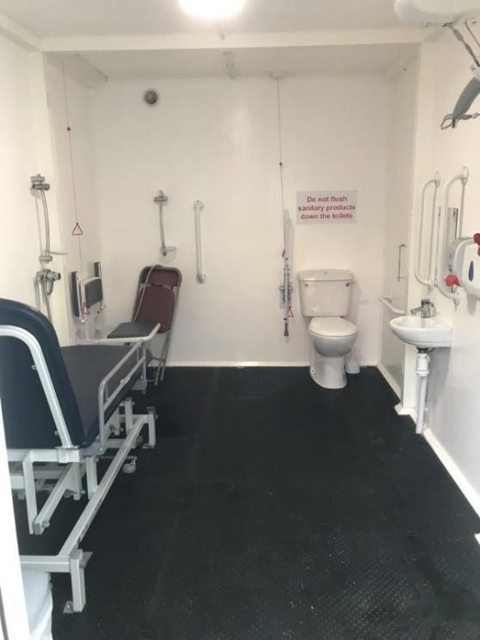
Here is an example of one of our High Dependency Units:

Contact us.

To contact a member of the customer service team, please submit a request on the FAQ page here:
https://help.hydeparkwinterwonderland.com/hc/en-gb/requests/new
For any ticketing queries, please contact See Tickets: https://winterwonderland.seetickets.com/customerservice

Other guides you may find useful:
These can be found on the Accessibility Page on our FAQs.
Nimbus Purchasing guide – A guide to booking your tickets, and PA tickets for entry, rides and attractions.
Ride Guide – A guide to all our rides. Including details about: lights, duration and physical movements.
Accessible Site Map – An accessible site map highlighting toilet locations, attractions, and loud and quiet areas.
Travel Guide – A travel guide highlighting the routes into Winter Wonderland if you are driving or arriving via public transport.
Please note – some of these guides are being updated with new and updated information and will be available as soon as possible. If you have any questions, please do contact our customer service team via the link above.

